/\*\*\*\*\*\*\*\*\*\*\*\*\*\*\*\*\*\*\*\*\*\*\*\*\*\*\*\*\*\*\*\*\*\*\*\*\*\*\*\*\*\*\*\*\*\*\*\*\*\*\*\*\*\*\*\*\*\*\*\*\*\*\*\*\*\*\*\*\*\*\*\*\*\*\*\*\*\*

Online Java Compiler.

Code, Compile, Run and Debug java program online.

Write your code in this editor and press "Run" button to execute it.

\*\*\*\*\*\*\*\*\*\*\*\*\*\*\*\*\*\*\*\*\*\*\*\*\*\*\*\*\*\*\*\*\*\*\*\*\*\*\*\*\*\*\*\*\*\*\*\*\*\*\*\*\*\*\*\*\*\*\*\*\*\*\*\*\*\*\*\*\*\*\*\*\*\*\*\*\*\*\*/

import java.util.Scanner;

public class Main

{

public static void main(String[] args) {

Scanner input = new Scanner(System.in);

Student s[]=new Student[3];

for (int i=0; i<s.length; i++)

{

System.out.print("Enter Roll No: ");

int r= input.nextInt();

System.out.print("Enter Name: ");

String n= input.next();

System.out.print("Enter Marks: ");

int m=input.nextInt();

s[i]=new Student (r,n,m);

}

int max=0;

for(int i=1;i<s.length;i++)

{

if(s[i].marks>s[max].marks)

{

max=i;

}

}

System.out.print("Maximum Marks :");

s[max].display();

for(int i=1;i<s.length;i++)

{

if(s[i].marks==s[max].marks)

{

if(i!=max)

{

System.out.print("Maximum Marks :");

s[max].display();

}

}

}

for(int i=0;i<s.length;i++)

{

for(int j=i+1;j<s.length;j++)

{

if(s[i].marks>s[j].marks)

{

Student temp=s[i];

s[i]=s[j];

s[j]=temp;

}

}

}

for (int i=0;i<s.length;i++)

{

s[i].display();

}

}

}

class Student {

int rollNo;

String name;

int marks;

Student(){

rollNo=0;

name="Name";

marks=0;

}

Student(int r, String n,int m)

{

rollNo=r;

name=n;

marks=m;

}

void display()

{

System.out.println(" Name :"+name);

System.out.println(" Roll Number :"+rollNo);

System.out.println(" Marks :"+marks);

}

}

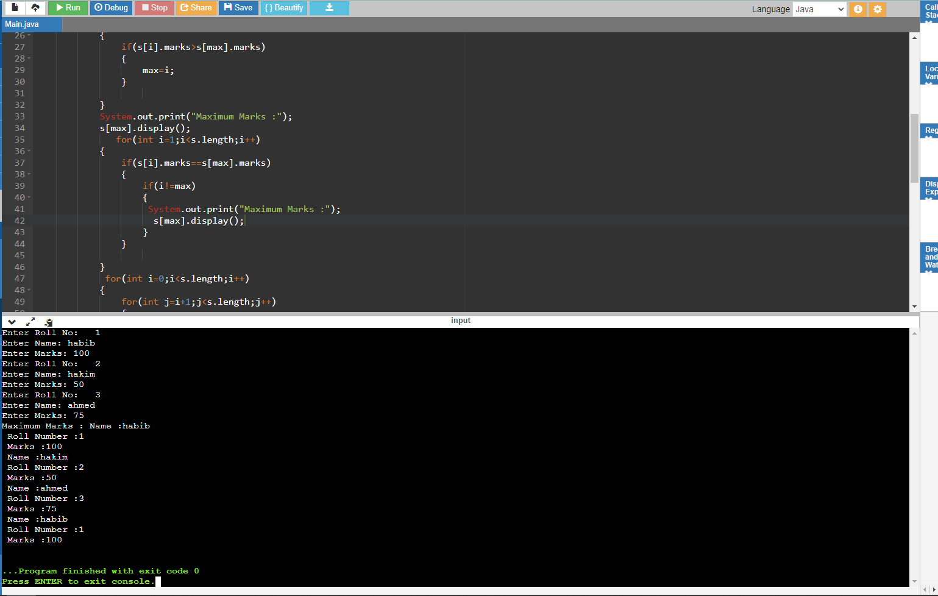

/\*\*\*\*\*\*\*\*\*\*\*\*\*\*\*\*\*\*\*\*\*\*\*\*\*\*\*\*\*\*\*\*\*\*\*\*\*\*\*\*\*\*\*\*\*\*\*\*\*\*\*\*\*\*\*\*\*\*\*\*\*\*\*\*\*\*\*\*\*\*\*\*\*\*\*\*\*\*

Online Java Compiler.

Code, Compile, Run and Debug java program online.

Write your code in this editor and press "Run" button to execute it.

\*\*\*\*\*\*\*\*\*\*\*\*\*\*\*\*\*\*\*\*\*\*\*\*\*\*\*\*\*\*\*\*\*\*\*\*\*\*\*\*\*\*\*\*\*\*\*\*\*\*\*\*\*\*\*\*\*\*\*\*\*\*\*\*\*\*\*\*\*\*\*\*\*\*\*\*\*\*\*/

public class Main

{

public static void main(String[] args) {

Person p1=new Teacher("Teacher");

Person p2=new Student("Student");

p1.speek();

p2.speek();

}

}

abstract class Person{

String name;

Person(String name)

{

this.name=name;

}

abstract void speek();

}

class Teacher extends Person{

Teacher(String name)

{

super(name);

}

@Override

void speek()

{

System.out.println(name+" is speaking!!");

}

}

class Student extends Person{

Student(String name)

{

super(name);

}

@Override

void speek()

{

System.out.println(name+" is speaking!!");

}

}

